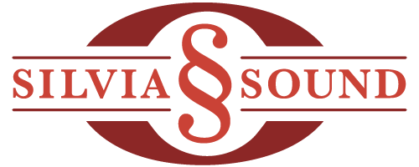

Silvia Piano Studio Policy 2022

Agreements:

1. Lessons are given on a weekly basis at the same time each week.

2. It is your responsibility to be sure all necessary books are brought to each lesson.

3. Payment will be a flat rate, the same each month, 12 months a year. This amount already accounts for several absences throughout year.

4. Payment, scheduling, and contact information will be handled via the Fons website.

5. When you book a trip out of town, please also cancel those lessons in the Fons website.

6. If a lesson must be cancelled due to illness, please notify me by phone by 9 a.m.

7. If your child is too sick to attend school, they are also too sick to attend piano lessons. Please plan to stay at home.

8. If I need to cancel a lesson for any reason, I will notify you well in advance. In case of my own illness, this notification will be no later than 9 am the morning of the lesson.

9. During inclement weather, we will attempt an online lesson at your regularly scheduled lesson time.

10. If your child is sick or you need to travel, possible make up lessons will be subject to my availability, coordinated through Fons. Do remember that I’ve already planned on several absences throughout the school year for both of us. Makeup lessons must occur within a month of the original cancellation.

11. All other circumstances that may arise will be handled on a case-by-case basis.

If you ever have any questions or concerns about your child’s musical education, please feel free to talk to me in person or to call me at home.

Thank you, and happy practicing!!

Sarah Silvia sarah.silvia@live.com (360) 620-8962

I have read and understand the agreement for the Silvia Piano Studio,

Signature:______________________________ Date:_______________
Please send a signed copy of this agreement with your student to their first lesson of the school year.

Contact Information
Please include the name and contact information of any adult that may be collecting your child.

Student’s Name: Age: Grade:

Parent’s Name:

Daytime phone number:

E-mail address:

Mailing address:

Photo Permission

I may wish to include a photo of your child on facebook or my website, perhaps with a special project, or a recital photo. These photos may include your child’s first name and age, but not their last name. My website is http://silviasound.com

Please indicate below:

: Yes, Sarah Silvia has my permission to include a picture of my child on her website.

: No, Sarah Silvia does not have my permission to include a picture of my child on her website.

Coronavirus Policies

- If your child’s school or school district resumes online teaching, please let me know so that we can plan for your family to receive online lessons.
- If my school district (Lake Washington School District) resumes online teaching, I will switch to online only instruction to match their decision.
- If anyone in your family has any symptoms or a quarantine, please call me so we can discuss switching your family to online lessons.
- Lessons can be unmasked at this time (early September). If you prefer to wear a mask, I will wear one, too.
- All students will continue to wash their hands before each lesson.

